AWS Cloud | Tips and Tricks | Migrating Legacy MySQL DB and Apps to AWS Cloud

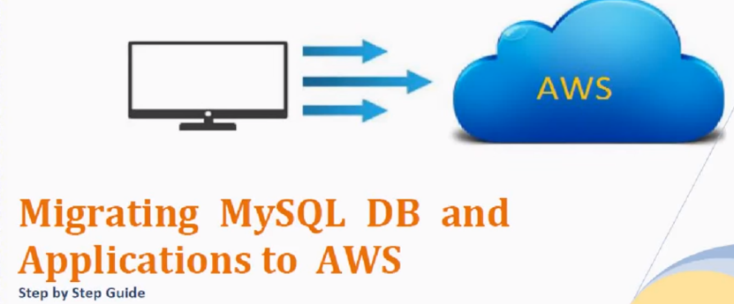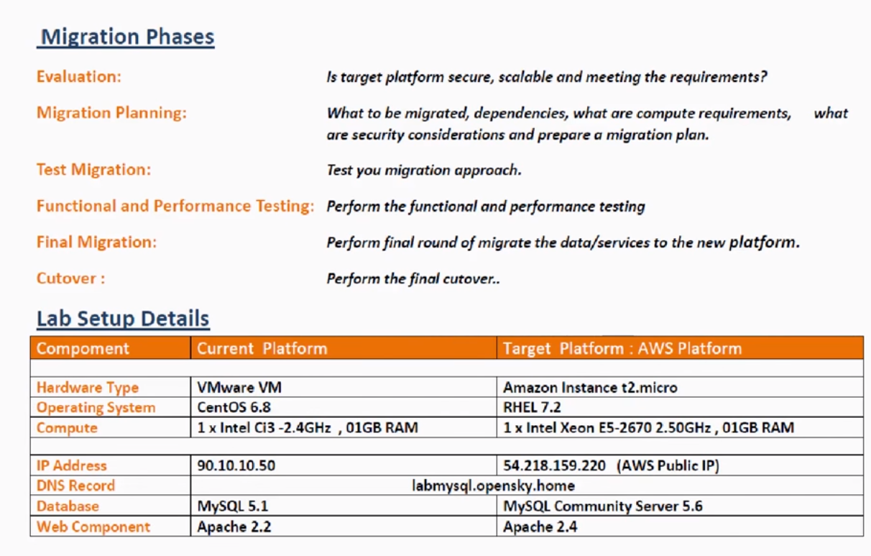

For selection resources: Check actual load on system.

On-premise:

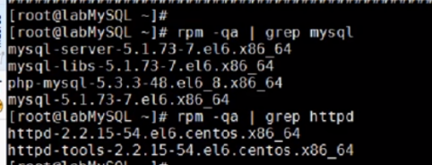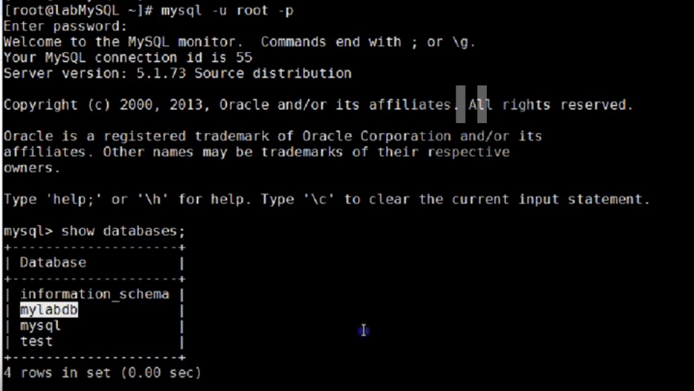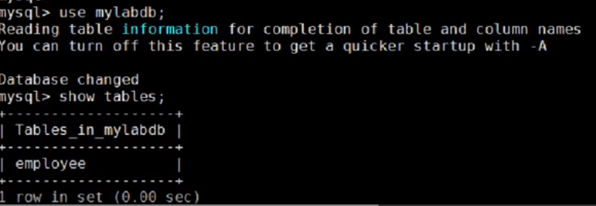

Mysql-5.1.3, apache-2.2.15..

DB: Login to DB…4 databases… On mylabdb have 1 table(employee).

Apache:



I’m using php to communicate to DB…My web browser will send query to php webbrowser, and php will get info. From Database…

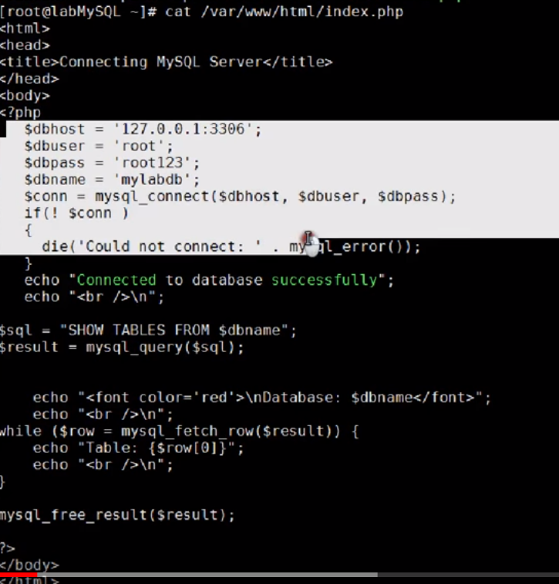

Page starts with html code.., and have php coding (DB name, connection string)…When php is able to connect to DB, it will show this message “Connected to Database successfully)”

I have written query also..To display tables from $dbname(mylabdb)

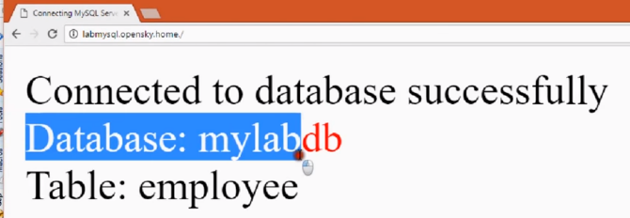

This is my existing setup..

Create a folder migration

Mkdir migration

1. Take backup of DB and webpages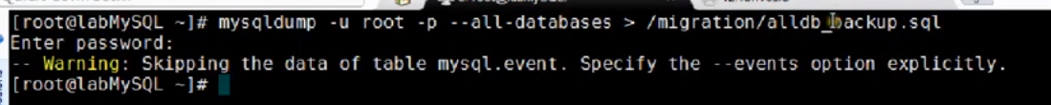

Dump all DBs and gzip



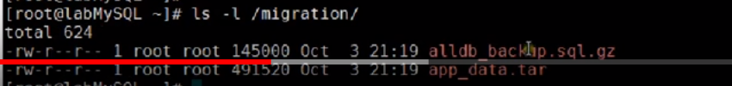

Migration folder have DB dump and webpages.

1. Copy ALL data to AWS instances ..

scp -i-🡪 to use .pem file

1. Connect to Ec2 instance.

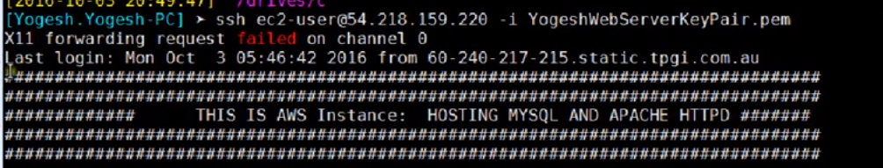

I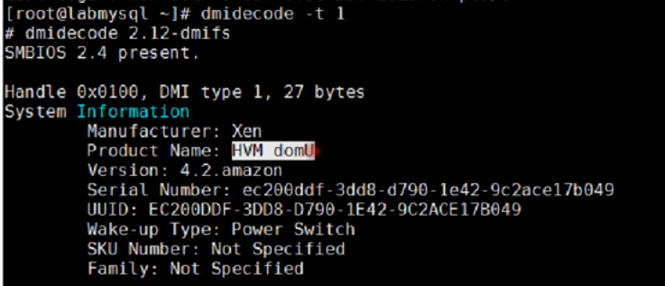

Dmidecode -t 1 -🡪Hardware Virtualization machine...

4.)We need 3 components

1. Mysql server
2. Apache webpage-🡪 httpd
3. Php🡪 to test connection b/w httpd and mysql

Php-mysql is existing for executing mysql commands

1. Enable and start services, and run mysql_secure_installtion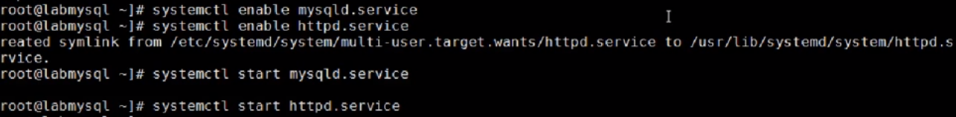

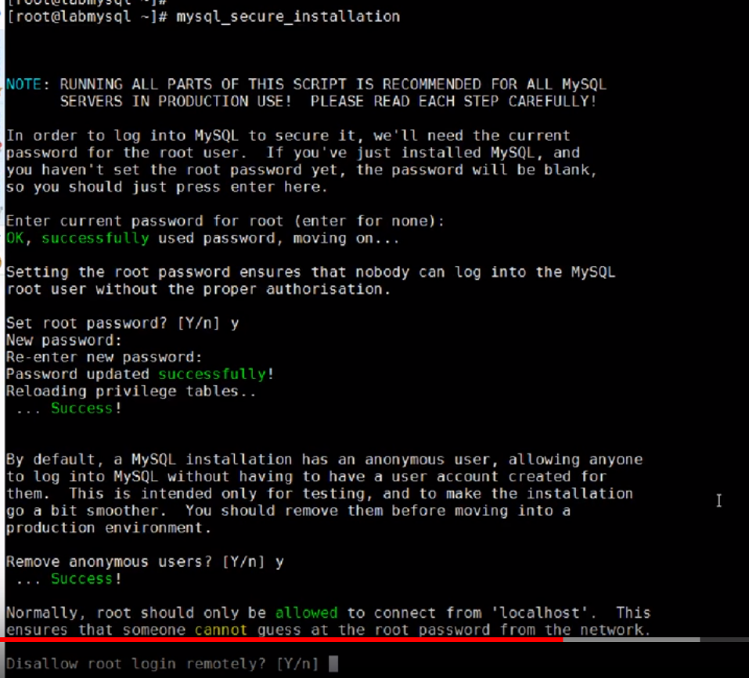

Unzip DB, webfiles….

6.)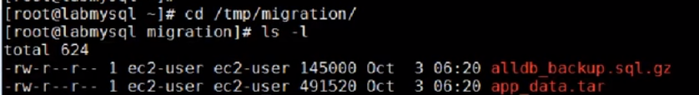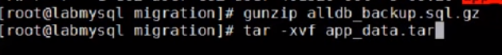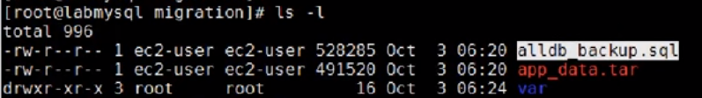

7.)First restore Db.., and try to connect it  
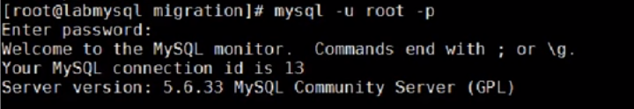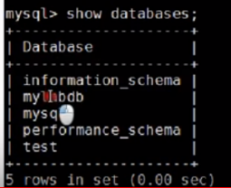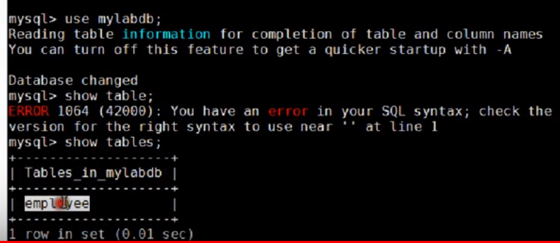

8.) Restore Web components: Move to www directory

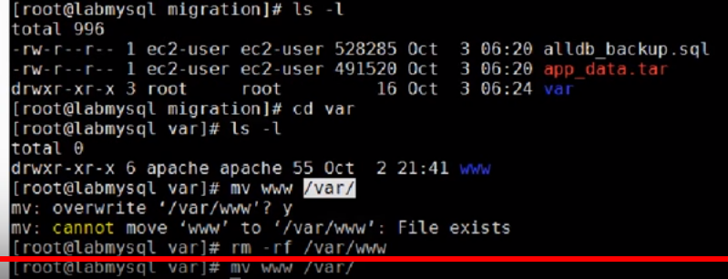

Test: It have my index.php file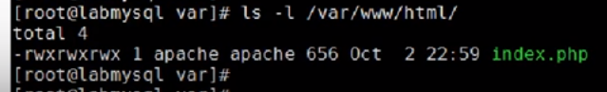

9.) Now restart mysql (DB) first and then Apache…

Because apache uses mysql and have dependency on it…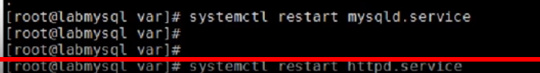

10.) Now, connect using publicIP:

